CONFIDENTIAL  CS/NOV 2026/ICT450

UNIVERSITI TEKNOLOGI MARA
MARKING SCHEME

COURSE :
COURSE CODE :
EXAMINATION :
TIME :
DATABASE DESIGN AND DEVELOPMENT
ICT450
NOVEMBER 2026 (MOCK)
3 HOURS

MARKING SCHEME NOTES

- This marking scheme accompanies the ICT450 mock paper (November 2026).
Answers are unofficial model answers, not official UTM marking schemes.

- Marking points state the expected answer and the allocation of marks; every question retains its source paper and page reference.

- Five questions x 20 marks; total = 100 marks.
- Real-bank questions: 5. Placeholders: 0.
Questions and answers are for local study use only.

- Structure derived from 12 unique ICT450 past papers; every real question remains traceable to its source page.

FOR MARKERS' USE ONLY

This marking scheme consists of 6 printed pages.
MARKING GUIDE
QUESTION 1 (20 marks)
Source: ICT450-2022-FEB · page [2, 3] · bank id ICT450-2022-FEB-Q1
Reference answer
(a) Four data items in online purchasing. [4 marks]
• Customer identity and contact data.
• Product ID, name, price and quantity.
• Order ID, order date and payment status.
• Delivery address and tracking information.
(b) Relational model features and importance. [4 marks]
• Data is represented as relations (tables) of rows and columns, with keys and integrity constraints.
• End users see a simple tabular view and can query it with SQL without knowing physical storage.
• Designers gain a logical, DBMS-independent structure that supports data independence and controlled redundancy.
(c) Keys and integrity for the academy tables. [12 marks]
• i) Superkeys include {STUDENT_IC}, {STUDENT_ID}, {EMAIL}, {STUDENT_IC, STUDENT_ID} and {STUDENT_ID, EMAIL}.
• Candidate keys: STUDENT_IC, STUDENT_ID and EMAIL, because each is unique and minimal.
• Primary key: STUDENT_ID — it is unique, stable and shorter than the IC.
• ii) STUDENT: entity integrity YES because STUDENT_ID is unique and non-null; referential integrity YES because every COURSE_ID exists in COURSE.
• COURSE: entity integrity YES because COURSE_ID is the unique primary key; referential integrity is not applicable because it has no foreign key.
Marking guide
• a) 1 mark for each of four data items (4).
• b) 2 marks for the features and 2 marks for importance (4).
• c)(i) 2 marks for superkeys, 2 for candidate keys and 2 for the primary key/reason (6).
• c)(ii) 3 marks for each table's integrity explanation (6).
Provenance: model_unofficial · confidence high · Model-authored from the approved question text, the supplied source assets and the ICT200/ICT450 knowledge base; no official ICT450 marking scheme was supplied.
Knowledge base basis: TOPIC 1 DATABASE CONCEPT (1).pdf; TOPIC 2 DATA MODEL (1).pdf; TOPIC 3 RELATIONAL DATA MODELstu.pdf
Assumptions / notes
• The STUDENT table has unique STUDENT_IC, STUDENT_ID and EMAIL values; the third table is the COURSE table shown.

QUESTION 2 (20 marks)
Source: ICT450-2024-JUL · page [3] · bank id ICT450-2024-JUL-Q2
Reference answer
(a) Match the data models with their statements. [4 marks]
• Hierarchical — records are organised in a strict parent-child tree; each child has one parent.
• Network — records are linked through sets and pointers, allowing many-to-many relationships.
• Relational — data is represented as tables with rows, columns and keys, queried with SQL.
• Entity Relationship — a conceptual model of entities, attributes and relationships, usually drawn as an ERD.
(b) Two business rules from the pet-shop schema. [4 marks]
• A customer can make many purchases, but each purchase is made by exactly one customer.
• A purchase can contain many pets, and each pet belongs to one purchase through PurchaseID.
• A pet has one species, age and price recorded.
(c) Three reasons for protecting data. [6 marks]
• Privacy and legal compliance — personal and financial data must not be exposed.
• Data integrity and trust — unauthorised changes can corrupt records and decisions.
• Business continuity and competitive advantage — theft or tampering can cause financial and reputational loss.
(d) Three multimedia data challenges. [6 marks]
• Large storage size — images, audio and video consume much more space than structured records.
• Complex indexing and retrieval — content-based search needs metadata and specialised indexes.
• Format and metadata diversity — many codecs, dimensions and formats must be normalised and described.
Marking guide
• a) 1 mark for each correct data-model description (4).
• b) 2 marks for each business rule (4).
• c) 2 marks for each reason (6).
• d) 2 marks for each challenge (6).
Provenance: model_unofficial · confidence medium · Model-authored from the approved question text, the supplied source assets and the ICT200/ICT450 knowledge base; no official ICT450 marking scheme was supplied.
Knowledge base basis: TOPIC 2 DATA MODEL (1).pdf; TOPIC 6 DATABASE DESIGN (1).pdf
Assumptions / notes
• The matching statements for the data-model table were not present in the extracted asset; the answer describes each model's matching statement.

QUESTION 3 (20 marks)
Source: ICT450-2023-JUL · page [3, 4] · bank id ICT450-2023-JUL-Q3
Reference answer
The reservation form stores a reservation header, a repeating list of menu items and one selected facility.
(a) Define normalization and its purpose. [3 marks]
• Normalization is the staged process of removing repeating groups, partial dependencies and transitive dependencies from relations.
• Its purpose is to reduce redundancy and prevent insertion, update and deletion anomalies.
(b) Three effects of poor database design. [6 marks]
• Data redundancy — the same customer or menu data is stored many times.
• Update anomalies — a change must be repeated in several rows and can become inconsistent.
• Insertion/deletion anomalies — a new menu cannot be added without a reservation, or deleting a reservation removes the only menu record.
(c) Normalise to 3NF. [11 marks]
1NF: one row per reservation-menu line; key (ReservationID, MenuCode).
Flattened relation.
RESERVATION (ReservationID, ReservationDate, CustomerID, CustomerName, MenuCode, MenuName, MenuDescription, Quantity, FacilityCode, FacilityName, FacilityDescription)
2NF: remove customer, menu and facility partial dependencies.
2NF/3NF relations.
CUSTOMER (CustomerID, CustomerName)
FACILITY (FacilityCode, FacilityName, FacilityDescription)
MENU (MenuCode, MenuName, MenuDescription)
RESERVATION (ReservationID, ReservationDate, CustomerID, FacilityCode)
RESERVATION_MENU (ReservationID, MenuCode, Quantity)
3NF: the remaining non-key attributes depend on their table keys; no transitive dependency remains.
Marking guide
• a) 3 marks: definition and purpose.
• b) 6 marks: 2 marks for each effect.
• c) 11 marks: 1NF (2), 2NF (4), 3NF (5).
Provenance: model_unofficial · confidence medium · Model-authored from the approved question text, the supplied source assets and the ICT200/ICT450 knowledge base; no official ICT450 marking scheme was supplied.
Knowledge base basis: TOPIC 5 NORMALIZATION (1).pdf
Assumptions / notes
• The reservation form asset is a blank template; the answer models one reservation with many menu lines and one optional facility.

QUESTION 4 (20 marks)
Source: ICT450-2023-FEB · page [5] · bank id ICT450-2023-FEB-Q4
Reference answer
Ninja Package schema.
RIDER (riderID, riderName, startDate, hpNum)
CUSTOMER (icNum, custName, custPhone, custAddress)
DELIVERY (packageID, dateDeliver, riderID, icNum, status)
(a) Create the DELIVERY table. [4 marks]
CREATE TABLE DELIVERY (
packageID VARCHAR(10) NOT NULL,
dateDeliver DATE,
riderID VARCHAR(10) NOT NULL,
icNum VARCHAR(20) NOT NULL,
status VARCHAR(15) NOT NULL
CHECK (status IN ('delivered', 'unsuccessful')),
PRIMARY KEY (packageID),
FOREIGN KEY (riderID) REFERENCES RIDER (riderID),
FOREIGN KEY (icNum) REFERENCES CUSTOMER (icNum)
);
(b) Customers successfully receiving packages in November 2022. [4 marks]
SELECT COUNT(DISTINCT icNum) AS "
"successful_customers
FROM DELIVERY
WHERE status = 'delivered'
AND dateDeliver BETWEEN DATE '2022-11-01' AND DATE '2022-11-30';
(c) Unsuccessful deliveries per rider. [4 marks]
SELECT riderID, COUNT(*) AS unsuccessful_deliveries
FROM DELIVERY
WHERE status = 'unsuccessful'
GROUP BY riderID;
(d) Rider names that made at least one delivery. [4 marks]
SELECT DISTINCT r.riderName
FROM RIDER r
JOIN DELIVERY d ON d.riderID = r.riderID;
(e) Produce Package ID, Customer Name and Status. [4 marks]
SELECT d.packageID, c.custName, d.status
FROM DELIVERY d
JOIN CUSTOMER c ON c.icNum = d.icNum
WHERE d.status = 'delivered';
Marking guide
• a) 4 marks: columns (1), primary key (1), both foreign keys (1), status check (1).
• b) 4 marks: delivered filter (1), date range (1), COUNT DISTINCT (2).
• c) 4 marks: unsuccessful filter (2), GROUP BY rider (2).
• d) 4 marks: rider-delivery join and DISTINCT names.
• e) 4 marks: join (2), selected columns (1), status filter (1).
Provenance: model_unofficial · confidence high · Model-authored from the approved question text, the supplied source assets and the ICT200/ICT450 knowledge base; no official ICT450 marking scheme was supplied.
Knowledge base basis: TOPIC 7 SQL.pdf
Assumptions / notes
• Status is limited to 'delivered' or 'unsuccessful' by a check constraint.

QUESTION 5 (20 marks)
Source: ICT450-2026-FEB · page [4, 5, 6] · bank id ICT450-2026-FEB-Q5
Reference answer
The ERD models customers, orders, products, order lines, invoices and delivery slots. ORDER_ITEM resolves the many-to-many order-product relationship.
(a) Construct the ERD with Crow's Foot notation. [16 marks]
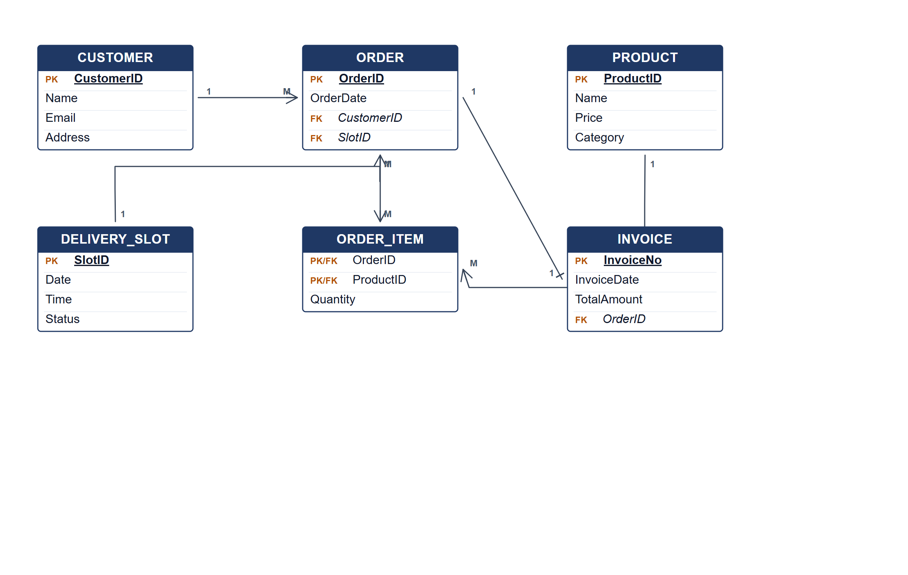
FreshBasket ERD.
(b) Two pieces of information from the ERD. [4 marks]
• The products and quantities in each customer order.
• The invoice total and delivery slot for each order.
Marking guide
• a) 16 marks: customer/order/product (5); order item, invoice and delivery slot (5); relationships and cardinalities (4); keys (2).
• b) 2 marks for each information item (4).
Provenance: model_unofficial · confidence high · Model-authored from the approved question text, the supplied source assets and the ICT200/ICT450 knowledge base; no official ICT450 marking scheme was supplied.
Knowledge base basis: TOPIC 4 ERD_stu (2).pdf; TOPIC 3 RELATIONAL DATA MODELstu.pdf
Assumptions / notes
• An order has exactly one invoice and one delivery slot; an order can contain many products.

